Does Social Media Improve Conflict Forecasting?
A Statistical Learning Analysis Using ViEWS and Twitter-Based Unrest Indicators
My, Haniya, Summer, Binayak
MATH 420: Statistical Learning · Augustana College
Instructor: A K M Raquibul Bashar, Ph.D. · Spring 2025–26

Abstract
This paper examines whether social media data can improve statistical learning models for conflict forecasting. Using a ViEWS-style country-month conflict dataset, we add four Twitter-based unrest indicators from the Civil Unrest on Twitter (CUT) dataset and compare a baseline model, which is built from structural political and economic variables, against a Twitter-enhanced model. The task is a regression prediction problem: predicting a continuous conflict intensity outcome from a set of country-month predictors. We explain the project using regression concepts, while the final empirical model is a mini-ensemble of three XGBoost regression models. Two model variants are evaluated on the same held-out test period (2018–2019). Globally, Twitter features worsen all four error metrics. In a subset of countries with recent Gen-Z protest activity, they improve every metric, with MSE falling by approximately 24%.

1. Introduction
Forecasting political conflict is a hard prediction problem: violence is rare, unevenly distributed across countries, and heavily shaped by each country's history. Systems like ViEWS (Violence & Impacts Early-Warning System) approach this by building regression models from slow-moving structural data such as economic conditions, past conflict, political institutions, and projecting forward month by month. Social media, by contrast, updates in real time. Protests are announced, grievances circulate, and mobilization occurs online before they appear in official records.
The central question of this paper is: do Twitter-based signals improve conflict predictions when added to a ViEWS-style model? To answer it, we build two versions of the same model, one with and one without Twitter features, hold all other settings constant, and measure which predicts better on data the model never saw during training.
The prediction task can be explained using the framework of multiple regression, although the final fitted model uses XGBoost regression. The regression equation says that conflict intensity in a given country-month is a weighted sum of measurable predictors plus random error. In the language of the model:
Conflict_{i} = β₀ + β₁(Conflict History) + β₂(GDP) + β₃(Political Stability) + β₄(Population) + β₅(Twitter Unrest Count) + β₆(Twitter Unrest %) + β₇(Twitter Non-Unrest Count) + β₈(Twitter Yearly Unrest Share) +...+ ε_{i}
▶ Each β (beta) is a number the model learns from training data. It tells us how much conflict intensity changes for every one-unit increase in that predictor, holding all other predictors fixed. ε captures everything the model cannot explain — irreducible randomness.
The paper follows the IMRaD format: Introduction, Methods, Results, and Discussion.

2. Research Questions and Hypotheses
Three research questions guide the project:
1. Does adding Twitter-based unrest indicators improve conflict prediction compared with the baseline ViEWS-only model?
2. Does the Twitter contribution differ between the global sample and countries with recent Gen-Z protest activity?
3. Can the difference in model performance be explained by the relationship between predictor quality and prediction error?

The main hypothesis is stated in null/alternative form. Let L_{B} denote prediction error for the baseline model and L_{T} prediction error for the Twitter-enhanced model. Lower error is better:
H₀: E(L_{T} − L_{B}) ≥ 0
▶ Null hypothesis: Twitter features do not reduce prediction error — they are useless or harmful.
H₁: E(L_{T} − L_{B}) < 0
▶ Alternative hypothesis: Twitter features reduce prediction error — they genuinely help the model.
We evaluate this by comparing error metrics on held-out test data. The model is fit on training data from 2014–2018 and judged on 2018–2019 data it never saw.

3. Models and Dataset

3.1 ViEWS and Conflict Forecasting
ViEWS (Violence & Impacts Early-Warning System) is a conflict forecasting framework that produces monthly predictions of armed violence at the country level. Predictors include conflict history, economic indicators, development metrics, and political variables. Our target variable is lr_ged_sb, a log-transformed measure of state-based conflict fatalities. This is a continuous numerical outcome, making the task a regression problem rather than a classification problem.

3.2 Civil Unrest on Twitter (CUT) Dataset
Twitter features are sourced from the Civil Unrest on Twitter (CUT) dataset (Sech et al., 2020), which contains English-language tweets from 2014 to 2019 annotated for civil unrest relevance. Tweet-level data are aggregated into country-month summaries compatible with the ViEWS format before being merged into the dataset. The Twitter variables are aggregated into four country-month features: unrest tweet count, non-unrest tweet count, percentage of tweets that are unrest-related, and the month’s share of yearly unrest tweets.

4. Methods

4.1 Study Design
The study uses a supervised learning design: each observation is a country-month with a known conflict outcome, the model is trained on historical data, and performance is evaluated on a held-out future period. The time split is fixed:
Training period: 2014–2018 (month_id 409–460)
Testing period: 2018–2019 (month_id 461–480)

Any difference in prediction error between the two models is attributable solely to the Twitter features, because all other settings, including data sources, time period, model architecture, and evaluation procedure, are held constant.

4.2 Key Variables
Outcome variable (what we predict):
lr_ged_sb: log-transformed count of state-based conflict fatalities for a given country in a given month. This is a continuous number; zero means no recorded fatalities, higher values mean more deaths. The log transformation reduces the influence of extreme outliers.

Baseline predictors (ViEWS-style structural variables):
The ViEWS-style dataset contains more than 200 predictors. For readability, we highlight several representative predictors here, including conflict history, GDP, political stability, and population.

Conflict History: lagged values of lr_ged_sb; how violent was this country in recent months?
GDP: gross domestic product per capita; a proxy for economic development and state capacity.
Political Stability: index measuring absence of political violence and terrorism.
Population: total population of the country; larger populations may have higher absolute fatality counts.

Twitter predictors (added in the enhanced model):
num_unrest_1_month: count of unrest-related tweets in this country-month.
num_unrest_0_month: count of non-unrest tweets in this country-month.
pct_unrest_1_month: percentage of all tweets in this country-month that are unrest-related.
pct_unrest_1_month_of_year: share of the country’s annual unrest tweets that fell in this specific month; captures whether this month is unusual relative to the year.

4.3 The Conflict Prediction Model
The project can be interpreted through the lens of multiple regression, in which conflict intensity is predicted from a set of explanatory variables. The full Twitter-enhanced model equation is:
Conflict_{i} = β₀ + β₁(Conflict History) + β₂(GDP) + β₃(Political Stability) + β₄(Population) + β₅(num_unrest_1_month) + β₆(pct_unrest_1_month) + β₇(num_unrest_0_month) + β₈(pct_unrest_1_month_of_year) +...+ ε_{i}
▶ The baseline model uses only β₀ through β₄ (no Twitter terms). The Twitter-enhanced model adds β₅ through β₈. Everything else is identical.
The model is fitted by minimizing the Residual Sum of Squares (RSS) — the total squared difference between observed and predicted conflict values across all training observations:
RSS = Σ_{i=1}^{n} (y_{i} − ŷ_{i})²
▶ The model finds the β values that make this sum as small as possible. Squaring each gap means large prediction errors are penalized far more than small ones.

4.4 Mini-Ensemble Prediction
The final empirical model is a mini-ensemble of three independently-trained XGBoost models. Their predictions are averaged to produce the ensemble output:
Ŷ_{ensemble} = (Ŷ₁ + Ŷ₂ + Ŷ₃) / 3
▶ Averaging three models reduces the risk that any single model’s errors dominate the final prediction. It is the same principle as averaging multiple estimates to get a more stable result.

4.5 Evaluation Metrics
Model performance on the test set is measured using four error metrics. In every case, lower values indicate better predictions. All four metrics are computed on held-out data that the model never saw during training.

Metric | Formula | What It Measures
MSE | (1/n) × Σ(Yᵢ − Ŷᵢ)² | Average squared prediction error. Heavily penalizes large misses.
MSLE | (1/n) × Σ(log(Yᵢ+1) − log(Ŷᵢ+1))² | MSE applied on the log scale. Treats proportional errors equally, regardless of whether conflict is high or low.
RMSLE | √MSLE | Square root of MSLE. Our primary metric because conflict fatalities are highly skewed - most country-months have near-zero values, a few are extreme.
CRPS | ≈ mean absolute prediction error | Measures the average size of prediction errors. Less sensitive to extreme outliers than MSE.

Why RMSLE is the primary metric: Because lr_ged_sb is log-transformed and conflict data are heavily right-skewed (many zeros, a few enormous values), the log-scale metric gives a fairer picture of model performance across all country-months rather than being dominated by a handful of extreme cases.

5. Results
Both models are evaluated on the 2018–2019 test period. Results are reported separately for the global sample and the Gen-Z protest-country subset.

5.1 Global Sample - Twitter Features Worsen Performance
In the global sample, the Twitter-enhanced model performs worse on every metric. Adding four Twitter features increased prediction error across the board:
Metric | Baseline Model | Twitter-Enhanced | Change
RMSLE (primary) | 0.648 | 0.680 | ↑ +0.032 (worse)
CRPS | 9.195 | 9.614 | ↑ +0.419 (worse)
MSE | 4219.35 | 4642.59 | ↑ +423 (worse)
MSLE | 0.420 | 0.462 | ↑ +0.042 (worse)

The MSE rose from 4,219 to 4,643 when Twitter features were added. This means the model’s average squared error on unseen test data increased after adding the new predictors - the Twitter features introduced more noise than signal in the global context.

5.2 Gen-Z Protest-Country Subset - Twitter Features Help
In the Gen-Z protest-country subset, the result reverses entirely. The Twitter-enhanced model performs better on every metric:
Metric | Baseline Model | Twitter-Enhanced | Change
RMSLE (primary) | 0.636 | 0.630 | ↓ −0.006 (better)
CRPS | 3.540 | 3.168 | ↓ −0.372 (better)
MSE | 80.52 | 61.46 | ↓ −19.06 (~24% better)
MSLE | 0.405 | 0.397 | ↓ −0.008 (better)

The ~24% drop in MSE (from 80.52 to 61.46) is the most striking result. It means the Twitter-enhanced model’s average squared prediction error in this subset is roughly a quarter lower than the baseline. Improvements are consistent across all four metrics, suggesting the result is not an artifact of a single measurement approach.
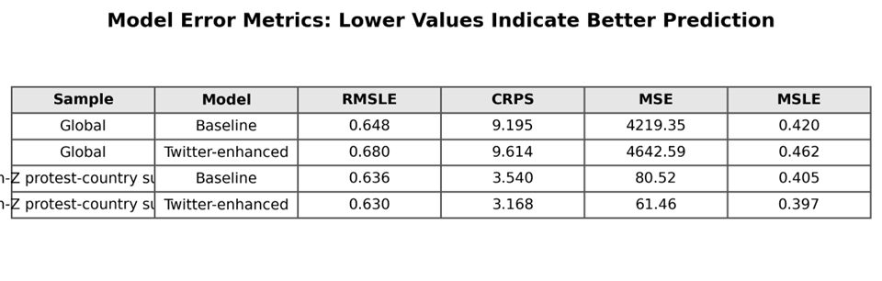
Figure 1. Error metrics for baseline and Twitter-enhanced models. Lower values indicate better prediction.
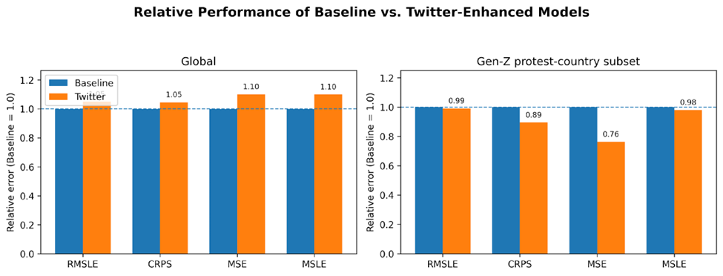
Figure 2. Relative error by metric, normalized so baseline = 1.0 within each sample. Values below 1.0 mean Twitter improves performance.

5.3 Summary
Main finding: Twitter features are not universally useful. They hurt global predictions by introducing noise, but genuinely improve predictions in countries where online protest discussion closely reflects real-world political instability.

6. Discussion

6.1 Why Twitter Helps in Some Countries
In countries with active Gen-Z protest movements, younger and more online populations use Twitter to discuss grievances, announce protests, and mobilize participation. When online discussion tracks real-world instability closely, variables like pct_unrest_1_month and num_unrest_1_month carry genuine predictive signal about conflict intensity in the coming month. These signals that slow-moving ViEWS variables cannot capture because those predictors update on yearly timescales.
In the broader global sample, Twitter activity is uneven across countries, languages, and political environments. In countries with low English-language Twitter adoption, num_unrest_1_month and num_unrest_0_month may reflect platform usage patterns more than actual unrest. In those cases, the Twitter coefficients β₅–β₈ pick up noise rather than signal, and the model’s predictions on unseen test data deteriorate.

6.2 Unrest vs. Conflict: A Measurement Mismatch
The Twitter variables measure discussion of civil unrest; the outcome variable lr_ged_sb measures state-based conflict fatalities. These are related but distinct. Not all protests escalate into armed conflict, and not all armed conflict is preceded by social media activity. The mismatch is smaller in Gen-Z protest countries, where protest activity and political violence are more closely linked, and larger in the global sample, where the two phenomena are less correlated.

6.3 Bias and Variance: Why Adding Predictors Can Hurt
The divergent results between the global sample and the Gen-Z subset reflect a fundamental tension in statistical learning: adding more predictors does not automatically improve predictions. When added predictors carry real signals, they reduce systematic error (bias), and the model improves. When added predictors carry only noise, they increase instability (variance) without reducing systematic error, and the model performs worse on new data. This is exactly what the results show:
Global sample: β₅–β₈ introduce noise. MSE rises by 423. The model fits irrelevant Twitter patterns in training data that do not generalize.
Gen-Z subset: β₅–β₈ carry genuine signal. MSE falls by 19 (~24%). The model learns a real relationship between online unrest and conflict.

6.4 Model Selection: When Are Extra Predictors Worth It?
Adding four Twitter features always costs something: more predictors mean a more complex model that is at greater risk of fitting noise. The question is whether the reduction in prediction error on the training set carries over to the test set. In the global sample, it does not - test MSE increases despite the larger model. In the Gen-Z subset, it does - test MSE falls by ~24%, a large enough improvement to clearly justify the added complexity.
This pattern is consistent with standard model-selection reasoning: a simpler model is preferred when added predictors do not meaningfully reduce out-of-sample error. That threshold is crossed in the Gen-Z subset but not globally.

7. Limitations and Future Work
(1) Simplified ViEWS-style model: This project uses a streamlined version of the ViEWS framework, not the full production pipeline.
(2) English-only, small Twitter dataset: The CUT data covers only English-language tweets, missing large portions of the world where political unrest is expressed in other languages.
(3) Platform coverage: Twitter is unequally adopted across countries. Future work should incorporate other platforms.
(4) Gen-Z subset definition: The protest-country subset was selected on theoretical grounds. Alternative definitions may yield different results.
(5) Outcome–feature mismatch: Twitter measures online discussion of unrest; the target variable measures armed conflict fatalities. Future work could test these features against protest-onset outcomes, which are conceptually closer to what Twitter captures.
(6) Formal regularization experiments: Fitting Ridge and Lasso variants of the conflict model with cross-validated regularization strength would directly test whether shrinking or eliminating the Twitter β coefficients recovers the global performance loss.

8. Conclusion
This project uses regression concepts and a mini-ensemble of XGBoost regression models to evaluate whether Twitter-based unrest indicators improve conflict forecasting.
Globally, the Twitter-enhanced model performs worse on all four error metrics (RMSLE, CRPS, MSE, MSLE). In the Gen-Z protest-country subset, it performs better on all four metrics.
The central lesson is that predictor quality matters more than predictor quantity. Adding variables whose β coefficients capture noise rather than signal increases prediction error on unseen data. The conflict regression model
Conflict = β₀ + β₁(Conflict History) + β₂(GDP) + β₃(Political Stability) + β₄(Population) + β₅(num_unrest_1_month) + β₆(pct_unrest_1_month) + β₇(num_unrest_0_month) + β₈(pct_unrest_1_month_of_year) +...+ ε
illustrates the general multiple regression principle on a real, socially meaningful problem: each β contributes to the prediction only if it reflects a genuine relationship between that predictor and the outcome. The results suggest that Twitter’s contribution to β₅–β₈ is real in protest-active countries and largely noise elsewhere.

References
Sech, J., DeLucia, A., Buczak, A. L., & Dredze, M. (2020). Civil Unrest on Twitter (CUT): A Dataset of Tweets to Support Research on Civil Unrest. Proceedings of the Sixth Workshop on Noisy User-generated Text (W-NUT 2020), 215–221.
Violence & Impacts Early-Warning System (ViEWS). (2026). Violence Early-Warning System. viewsforecasting.org.
Bashar, A. K. M. R. (2025–2026). MATH 420 Augustana College, Department of Mathematics and Computer Science.
Chen, T., & Guestrin, C. (2016). XGBoost: A scalable tree boosting system. Proceedings of the 22nd ACM SIGKDD International Conference on Knowledge Discovery and Data Mining, 785–794.

